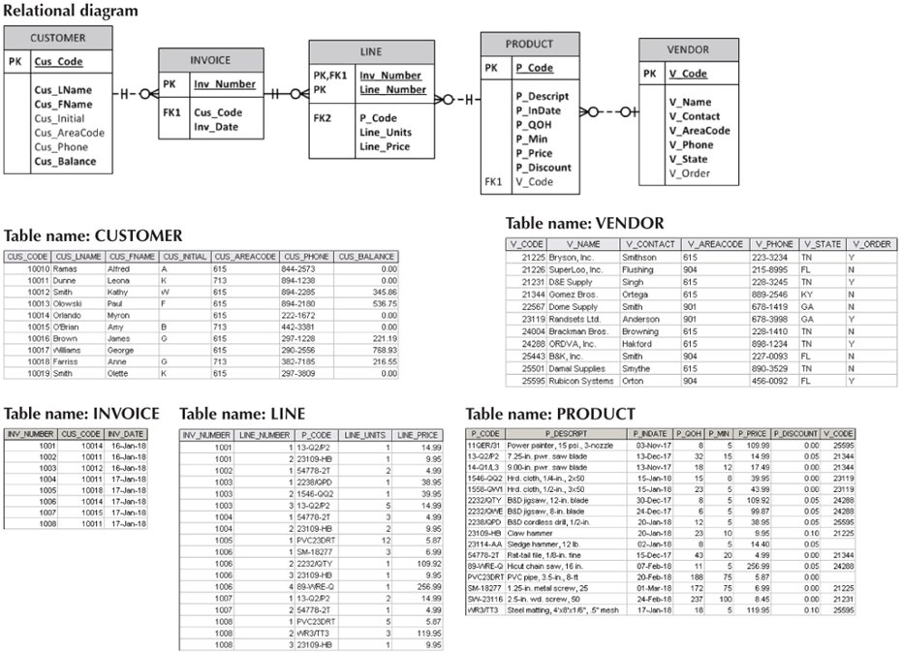

1. Write a SQL statement that will list all the columns of the table Line.

Select * from dbo.LINE

1. Write a SQL Statement to list the P_Descript column of the product table and the character count and byte count for each description.

Select P_DESCRIPT, Len(P_DESCRIPT), DataLength(P_DESCRIPT) from dbo.PRODUCT

1. Write a SQL Statement to list the customers full name as a single column, and order the results by last name, then first name.

Select CUS_LNAME + ‘ ‘ + CUS_FNAME as Full_Name

From dbo.CUSTOMER

Order by CUS_LNAME ASC,

CUS_FNAME ASC

1. Write a SQL Statement to list all customers and invoices, if any.

To List all customers:

Select

CUS_LNAME + ‘ ‘ + CUS_FNAME as Full_Name,

CUS_CODE

From dbo.CUSTOMER

To List all invoices:

Select * from dbo.INVOICE

To List all customers with invoices:

Select

CUSTOMER.CUS_LNAME + ‘ ‘ + CUSTOMER.CUS_FNAME as Full_Name,

CUSTOMER.CUS_CODE,

INVOICE.INV_NUMBER,

INVOICE.INV_DATE

From CUSTOMER

INNER JOIN

INVOICE

On CUSTOMER.CUS_CODE = INVOICE.CUS_CODE

1. Write a SQL Statement to list all Invoice line numbers and the corresponding description for the product and order by the price of the product.

Select

LINE.INV_NUMBER,

LINE.LINE_NUMBER,

LINE.P_CODE,

PRODUCT.P_DESCRIPT

From LINE

LEFT OUTER JOIN

PRODUCT

ON

LINE.P_CODE = PRODUCT.P_CODE

ORDER BY PRODUCT.P_PRICE ASC